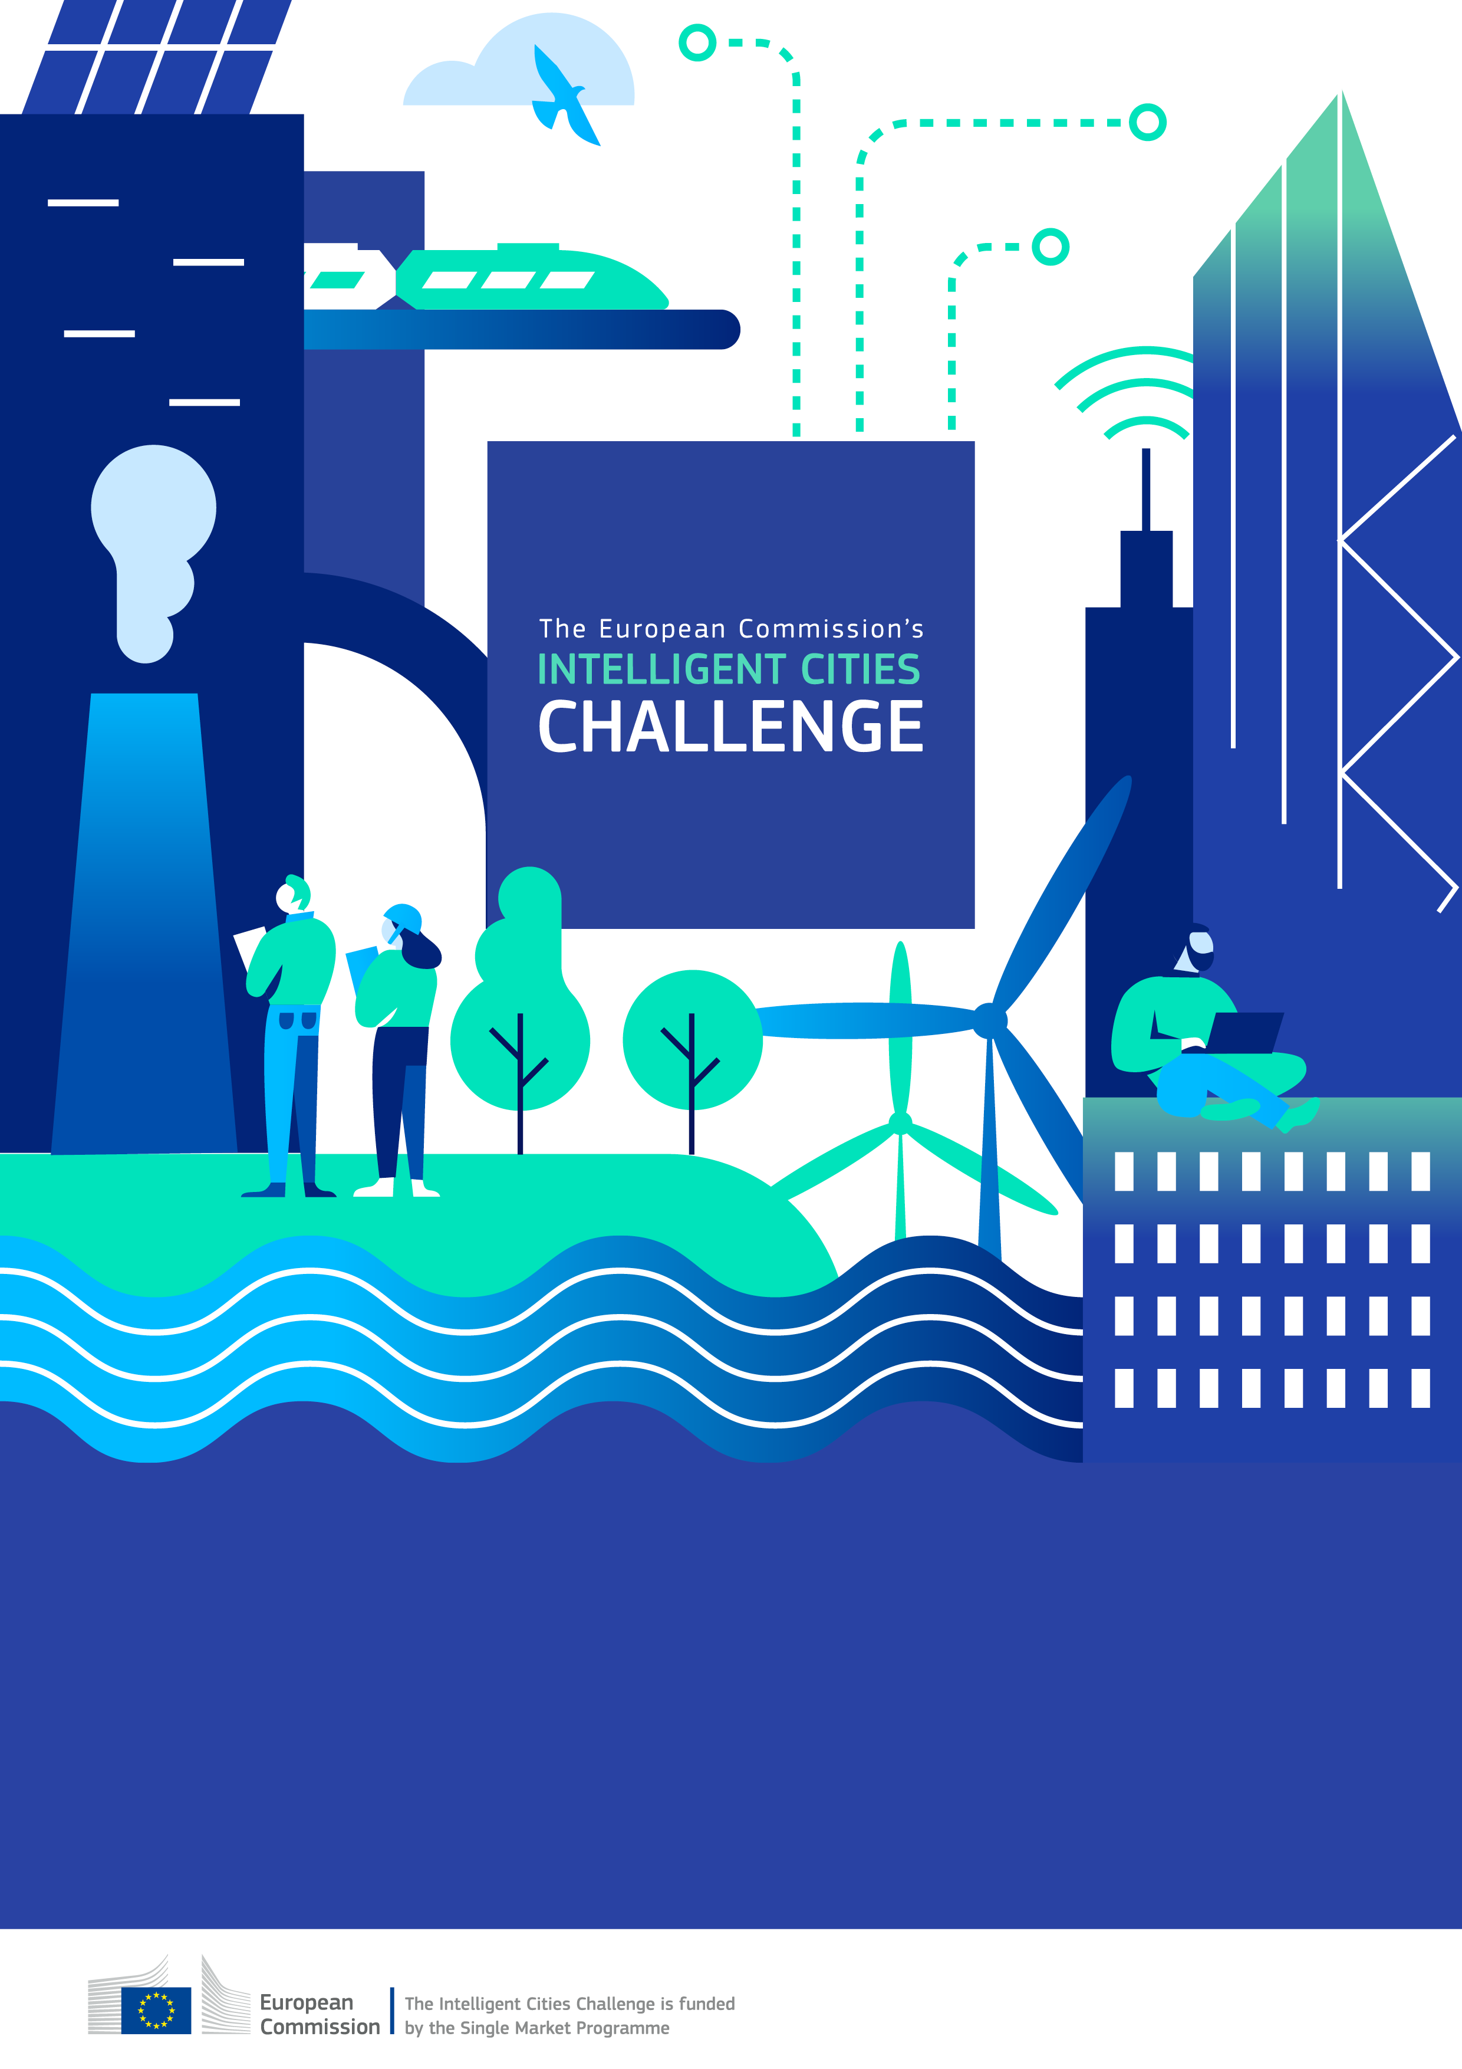
Legnano Local Green Deal
Energy audits for MSMEs
Municipality of Legnano, Confindustria Alto Milanese,
Università degli studi di Milano, Università degli studi di Brescia, PTSCLAS

LOCAL GREEN DEAL in LEGNANO

PREMISE
Legnano is an urbanized city of about 60k inhabitants, historically industrial, now more focused in trade and services but still with an important presence of manufacturing enterprises.
The city is geographically located in the Po Valley, one of the most air polluted areas of the national territory. In part this depends on a very particular geographic configuration to which, however, is associated a very high concentration of urban and manufacturing activities.
In the area around Legnano there are about 300 industrial enterprises, many of which are highly energy consuming and have a strong environmental impact. Commercial and artisanal activities are also widespread with more than 1,500 enterprises. In addition, the strong urbanization and centrality of the city in the Upper Milanese Area brings with it a very high and increasing traffic concentration over the years.
In recent years, thanks in part to the large amount of funds received from various European, national, and regional sources, the municipality of Legnano has undertaken a path of profound transformation in the direction of environmental sustainability. Most of the investments have been focused on a few crucial areas: the use of renewable energy on the existing municipal housing stock, the progressive transformation of urban mobility, the redesign of public spaces, the reduction of undifferentiated waste and the increase of recycling and recovery of materials.
The municipality of Legnano intends to use the Local Green Deals “Energy audits for micro, small and medium-sized enterprises” as a strategic governance approach to accelerate sustainability action at the local level, in line with the goals of the European Green Deal.
The municipality of Legnano seeks to sign individual LGDs to implement its sustainability strategy named “Urban Regeneration” (PNRR - MISSION 5 - COMPONENT 2 - INVESTMENT SUB-INVESTMENT 2.1) and to reach its stated goals.

The present LGD is designed with the following role of the municipality of Legnano and will define each signatories’ contributions accordingly in the subsequent sections.
- City as contributor (e.g. City-to-Business).
i.e. The local government is an active contributor to measures committed to by one or more businesses, NGOs, municipal companies, or business intermediaries, like Chamber of Commerce, business associations, etc.

Local Green Deal between Confindustria Alto Milanese, Università degli studi di Milano, Università degli studi di Brescia, PTSCLAS and the Municipality of Legnano

- Scope of the Local Green Deal
Energy-efficiency initiatives are crucial to reduce environmental impact and promote sustainability, but to achieve real energy efficiency a preliminary energy audit is strongly recommended. In this perspective, planned LGD’s first target is focused on increasing the number of enterprises willing to carry out an energy audit.
This becomes an essential step to identify areas where (through analysis of the energy consumption to identify inefficiencies, waste, or potential improvements) energy efficiency can be improved and energy can be saved.
An appropriate audit can enable suitable strategies to be developed and implemented to reduce energy consumption and optimise the use of available resources.
All this is consistent with and completes the urban regeneration plan of the municipality of Legnano. Until now, in fact, the energy efficiency measures promoted by the administration have been focused only on public buildings and facilities; with this initiative, on the contrary, the design is extended to the small and medium-sized enterprises in the area.
From a sectorial point of view, the planned LGD is something between “Construction and Building” and “Renewable energy” since energy audits are prodromal to possible subsequent actions both in terms of energy savings (through improvements aimed at optimising the efficiency of buildings and the production processes) and the use of alternative sources of energy generation.
The implementation of energy-audit LGDs brings several benefits to enterprises in terms of costs and long-term sustainability:
- Identifying inefficiencies and recommending energy-saving measures, an energy audit can significantly lower utility bills and help prioritize upgrades that offer the best return on investment.
- Pinpointing areas of excessive energy consumption, energy audit allows for targeted improvements in the energy use and can lead to better maintenance and upgrades of existing equipment.
- Ensuring compliance with environmental laws and regulations can be facilitated through an energy audit.
- An energy audit provides valuable data for long-term energy planning and management and helps in preparing for future energy needs and regulatory changes.
- Energy audit can make easier to access to incentives, rebates, and grants for energy efficiency improvements.
- Demonstrating a commitment to sustainability can enhance a company’s reputation and brand image in the local, national and international environment.

The ultimate aim of the initiative is to promote energy-saving initiatives in the city's productive sector, thereby generating combined benefits for both the companies and the citizens. By reducing energy consumption, enterprises can save on costs freeing up resources that can be reinvested in other projects that could benefit the city. In addition, reduced energy consumption leads to lower emissions of greenhouse gases and other air pollutants, improving air quality and reducing health risks for residents. At the same time, energy saving initiatives can stimulate job creation in renewable energy, energy efficiency and green technology, contributing to local economic growth. In a broader view, by reducing air pollution and promoting sustainable practices, the city can finally improve the quality of the urban environment, making it more attractive, pleasant and healthy.

The activity of project development and stakeholder involvement took place in several stages over a time horizon of approximately five months. Meetings with each of the partners (see below) have been organized in order to present and drive the initiative: initially, meetings were held mainly to illustrate the project and share the general framework and macro-objectives; afterwards several more specific meetings were held for discussion and fine tuning to agree, step by step, on segmentation, objectives and methodology. Altogether, in five months, there were about 25 meetings with the different partners involved in the LGD Energy project.

The agreed working methodology used in these months, up to the signing of the LGD was as follows:
1. Mapping of enterprises by sector, activity, turnover, number of employees, etc. in order to have a general view of the local productive environment.
2. Identification, through analysis of literature data and open discussions with technicians and specialists from Confindustria and Enea, of the “state of art” and the most critical elements concerning energy efficiency (and energy audits) in MSMEs.
3. Organisation and management of Focus Groups and One-to-One Interviews on a sample of enterprises (selected by Confindustria) in order to verify the preliminary hypotheses, identify new areas of investigation and segmentation variables, gather suggestions and opinions, identify possible barriers to (and the degree of interest in) an energy audit.
4. Design (by the University of Milan and the University of Brescia in cooperation with PTSCLAS), of a research study (structured survey) to verify the willingness of companies to carry out an energy audit and its dependence from different variables to be tested.
5. Preparation (also in cooperation with Enea) of the questionnaire and design/selection of the questionnaire delivery methodology.
- Pilot and fine tune the questionnaire through autonomous and guided filling in of the questionnaire by a sample of companies, in meetings specifically organised to check how easy or not the compilation was, and to identify possible areas for improvement.

Partners to the Local Green Deal

Partner 1: Confindustria Alto Milanese
Organization type: Manufacturers’ association

Confindustria's sustainability objective is to promote energy audits among associated enterprises in the area and, in this way, promote energy efficiency measures with a direct impact on business costs and, more generally, on long term business sustainability of the enterprises.
Confindustria, General Confederation of Italian Industry, is the largest association representing manufacturing and service companies in Italy. Confindustria has initiated many activities to ensure a central role for Italy in the definition and implementation of the European Green Deal, continuing and reinforcing action aimed at achieving environmental objectives, promoting energy markets and industrial competitiveness. In addition, it has already planned the strengthening of information, training and awareness-raising activities for managers and companies on Circular Economy issues, and the monitoring of the activation of economic measures to support companies in the ecological transition, towards business models and investments for the circular economy.
Confindustria Alto Milanese is the manufacturers’ association of industrial enterprises in the Upper Milanese area, of whom it represents the interests in their relations with institutions, trade unions and social organisations and offers assistance and specialised services concerning company business and management. It has 437 member companies. Overall, the organisation represents about 40% of the local enterprises (about 60% in terms of turnover and number of employees).
Confindustria Alto Milanese is a recognised and accredited institution in the local world of manufacturing, and thanks to its high regard and trust among the companies in the area, it is a strategic reference point for the project. And it will be essential to promote the implementation of the LGD among the associated enterprises.

Partner 2: Università degli Studi di Milano - Dept. of Economics, Management and Quantitative Methods (DEMM).
Organization type: Academic institution

The University's aim, as part of its research studies on behavioural economics applied to the environment and environmental sustainability, is to identify the most effective ways of involving small and medium-sized enterprises in environmentally sustainable choices and behaviour. In particular, in this case, the objective is to identify the main barriers and the most effective incentives for companies to adopt an energy audit (as a first step for a possible energy efficiency intervention), analysing the impact of different engagement tools depending on the type of company and entrepreneur. All this by applying suitable and rigorous scientific research methodologies.
The Department of Economics, Management and Quantitative Methods (DEMM) of the University of Milan focuses its studies in the fields of economics, business and mathematics-statistics. For the second consecutive five-year period, it has been named a Department of Excellence by the MUR. Department members conduct research on a wide range of topics and publish the results in national and international journals of high scientific standing. In the field of economics, the DEMM has expertise mainly in the area of applied and behavioural economics and is among the founders of the Milan Economic Impact Evaluation Centre (MEIEC), a research centre whose mission is spreading a culture of evidence-based policy making and impact evaluation of public policies.
DEMM covers a crucial role in the LGD design and implementation and is fully committed in the identification, by means of appropriate statistical methodologies, of the most effective ways to activate the participation and involvement of companies in the energy audits. And to verify, ex post, the effectiveness and sustainability of different approaches, providing useful and essential guidance for further developments that can be applied by the municipality.

Partner 3: Università degli Studi di Brescia - Dept. of Economics and Management.
Organization type: Academic institution

The University's aim, as part of its research studies on behavioural economics applied to the environment and environmental sustainability, is to identify the most effective ways of involving small and medium-sized enterprises in environmentally sustainable choices and behaviour. In particular, in this case, the objective is to identify the main barriers and the most effective incentives for companies to adopt an energy audit (as a first step for a possible energy efficiency intervention), analysing the impact of different engagement tools depending on the type of company and entrepreneur. All this by applying suitable and rigorous scientific research methodologies.
The Department of Economics and Management of the University of Brescia was established in 2012 from the union of the Departments of the Faculty of Economics, which over the years have been able to integrate their scientific and teaching skills, developing innovative projects in the various fields of economics. The Department's research activity reflects its multidisciplinary nature, with more than seventy researchers active in their areas of expertise. Over time, an increasing number of them have accumulated significant research experience in international settings, taken on leadership roles in national and European scientific societies, and coordinated research projects of national and international relevance.
The Department of Economics and Management of the University of Brescia covers a crucial role in the LGD design and implementation and is fully committed in the identification, by means of appropriate statistical methodologies, of the most effective ways to activate the participation and involvement of companies in the energy audits. And to verify, ex post, the effectiveness and sustainability of different approaches, providing useful and essential guidance for further developments that can be applied by the municipality.

Partner 4: PTSCLAS SPA
Organization type: Private company

PTSCLAS, formerly Gruppo CLAS, is a consulting company that offers an interdisciplinary approach that integrates Consulting, Digital Innovation, and Communication, structuring its services in key sectors for Italian development in a highly synergistic manner. PTSCLAS now has over 200 professionals with diverse skills, including many experts in data analysis, computer science, and statistics applied to public policy evaluation. The company possesses specific expertise in handling statistical databases related to various sectors (businesses, labour, education, culture, infrastructure, etc.). PTSCLAS has extensive experience in the monitoring and evaluation of public policies and projects. Since the 1994-1999 programming period of the European Structural Investment Funds, it has gained deep knowledge of programmes and project concerning innovation and competitiveness in SMEs, sustainable mobility and digital infrastructures, thanks to significant experience in the evaluation and technical assistance of programs co-financed by the European Union. The added value of these experiences is reflected in the mastery of various evaluation methods and tools (econometric and counterfactual analyses, interviews, case studies, online surveys, etc.), the understanding of public policies related to the areas of analysis, and the knowledge of the contexts in which the interventions to be evaluated are implemented.
PTSCLAS has recently started a collaboration with MEIEC (Milan Economic Impact Evaluation Centre), a research centre founded in the spring of 2023 by the University of Milan and the Institute for Evaluative Research on Public Policies of the Bruno Kessler Foundation, with PNRR funding. The MEIEC was created with the goal, shared by PTSCLAS, of raising awareness and attention among public institutions, businesses, and civil society on the importance of impact evaluation of policies in making 'evidence-based' decisions. In this context, PTSCLAS will contribute its extensive experience in supporting the evaluation of LGD impact considering both the efforts of public and private organizations and providing recommendations for improvement where necessary.

Supporting Partner: Enea
Organization type: Publicly owned company

For Enea, energy audits in SMEs are an objective of primary importance as they play a crucial role in the decision of companies to improve energy efficiency. Since a long time, Enea has been committed to promoting energy audits in SMEs through the provision of tools, the organisation of events, and cooperation with local authorities. In this perspective the primary objective of its supporting activities in the LGD implementation is to promote energy audits in small and medium enterprises in the Upper Milanese territory.
Enea is the National Agency for New Technologies, Energy and Sustainable Economic Development, a public law body dedicated to research, technological innovation and the provision of advanced services to enterprises, public administration and citizens in the fields of energy, environment and sustainable economic development. They have been involved in the project to give technical and knowledge support on specific energy efficiency issues, providing know-how, specific tools and human resources to help companies in their energy audits and in the identification of the most appropriate energy saving and efficiency measures to be implemented.

- Specific measures and monitoring

Municipality of Legnano commits to:
Scope/sector | Energy audits
Action | Enhance the number of MSME committed and willing to carry out an energy audit, by means of massive communications, press conferences and other institutional channels. Prepare a call for tender to be used as one of the incentive approaches to be tested in the survey (see below)
Target | At least 20% of Confindustria Alto Milanese associated companies (local territory only) to carry out an energy audit by July 2025.
Impact | Number of energy audit carried out by Confindustria Alto Milanese associated companies.  Primary energy potentially saved (KWh or Tep)  % primary energy potentially saved/total  CO₂ emissions avoided (ton)
Contribution by third party/ stakeholders (optional) | ENEA: Make the energy audit tool available, train the technical staff who will support companies to correctly use the tool, participate in an event to launch the energy audit programme.
Cost estimation | EUR 70.000 approximately (subject to the previous and necessary management, administrative and political acts)
Funding source | ☐ Private ☒ Public ☐EU Funding ☐ Other (please specify)
Timeline/ Deadline | July 2025
Monitoring activities | The action will be monitored by the municipality on the achievement of the KPI “% of audit carried out”. A bimonthly report will be produced containing the following information:  - Name LGD and Date  - Activities carried out  - KPI assessment.  The KPIs related to the environmental performances will be monitored at the end of the activities.

Confindustria Alto Milanese commits to:
Scope/sector | Energy audits
Action | Enhance the number of MSME committed and willing to carry out an energy audit, by means of direct contacts, massive communications, press conferences and other institutional channels.
Target | At least 20% of Confindustria Alto Milanese associated companies (local territory only) to carry out an energy audit by July 2025
Impact | Number of energy audit carried out by Confindustria Alto Milanese associated companies.  Primary energy potentially saved (KWh or Tep)  % primary energy potentially saved/total  CO₂ emissions avoided (ton)
Contribution by third party/ stakeholders (optional) | ENEA: Make the energy audit tool available, train the technical staff who will support companies to correctly use the tool, participate in an event to launch the energy audit programme.
Cost estimation
Funding source | ☐ Private ☐ Public ☐EU Funding ☐ Other (please specify)
Timeline/ Deadline | July 2025

Università degli Studi di Milano commits to:
Scope/sector | Energy audits
Action | Design a research approach, carry out a survey to measure the willingness of companies to undertake an energy audit, assess the varying effectiveness of a set of incentive tools, support the implementation of energy audits and measure, over time, their correlation with energy efficiency measures.
Target | Complete the survey field activities by March 2025.  Implement the energy audit in the selected companies, by July 2025.  Provide a report in which the most effective ways to activate the participation and involvement of companies in the energy audits are identified and analysed. With punctual measurement of correlations with selected qualitative and quantitative characteristics of the enterprises, by September 2025.
Impact | Number of energy audit carried out by Confindustria Alto Milanese associated companies.  At least one scientific article on the results of the survey, to be disseminated through scientific conferences, academic peer-reviewed journals and workshops with stakeholders and policy makers.
Contribution by third party/ stakeholders (optional) | ENEA: Make the energy audit tool available, train the technical staff who will support companies to correctly use the tool, participate in an event to launch the energy audit programme.
Cost estimation | EUR 17.000
Funding source | ☐ Private ☒ Public ☐EU Funding ☐ Other (please specify)
Timeline/ Deadline | September 2025

Università degli Studi di Brescia commits to:
Scope/sector | Energy audits
Action | Design a research approach, carry out a survey to measure the willingness of companies to undertake an energy audit, assess the varying effectiveness of a set of incentive tools, support the implementation of energy audits and measure, over time, their correlation with energy efficiency measures.
Target | Complete the survey field activities by March 2025.  Implement the energy audit in the selected companies, by July 2025.  Provide a report in which the most effective ways to activate the participation and involvement of companies in the energy audits are identified and analysed. With punctual measurement of correlations with selected qualitative and quantitative characteristics of the enterprises, by September 2025.
Impact | Number of energy audit carried out by Confindustria Alto Milanese associated companies.  At least one scientific article on the results of the survey, to be disseminated through scientific conferences, academic peer-reviewed journals and workshops with stakeholders and policy makers.
Contribution by third party/ stakeholders (optional) | ENEA: Make the energy audit tool available, train the technical staff who will support companies to correctly use the tool, participate in an event to launch the energy audit programme.
Cost estimation
Funding source | ☐ Private ☐ Public ☐EU Funding ☐ Other (please specify)
Timeline/ Deadline | September 2025

PTSCLAS commits to:
Scope/sector | Policy evaluation
Action | Cooperate with MEIEC (see University of Milan) with the goal of raising awareness and attention among public institutions, businesses, and civil society on the importance of impact evaluation of policies in making 'evidence-based' decisions.
Target | Support the organization of dissemination events by engaging public partners and private organizations and delivering presentations on the significance of evaluation by March 2025.  Support and coordinate the implementation of an LGD monitoring tool and the release of a first policy evaluation report (based on companies’ profiles and related response rates) by July 2025.
Impact | Help build a stronger network among local actors, encouraging greater collaboration across sectors and influencing the implementation of future public and private initiatives.  Strengthen the culture of evaluation, promoting continuous improvement in both governance and business practices, with long-term benefits for local development and competitiveness.
Contribution by third party/ stakeholders (optional) | ENEA: Make the energy audit tool available, train the technical staff who will support companies to correctly use the tool, participate in an event to launch the energy audit programme.
Cost estimation | None
Funding source | ☐ Private ☐ Public ☐EU Funding ☐ Other (please specify)
Timeline/ Deadline | July 2025

Legnano, 17.12.2024

Comune di Legnano  [Il Sindaco]  Lorenzo Radice | Confindustria Alto Milanese  [il Direttore]  Andrea Pontani

Università degli Studi di Milano  [Il Professore Associato]  Giovanna d’Adda  [name]  PTSCLAS SpA  [Executive Vice President]  Alberto Miglietta |  | Università degli Studi di Brescia  [il Rettore]  Francesco Castelli

Please quantify the impact to the greatest extent possible. You may want to use the Input-Output-Outcome-Impact model or similar for impact measurement.
Please quantify the impact to the greatest extent possible. You may want to use the Input-Output-Outcome-Impact model or similar for impact measurement.
Please quantify the impact to the greatest extent possible. You may want to use the Input-Output-Outcome-Impact model or similar for impact measurement.
Please quantify the impact to the greatest extent possible. You may want to use the Input-Output-Outcome-Impact model or similar for impact measurement.

